One of the software that may be used for generating machine readable doucment is Adobe Acrobat DC. Steps for generating machine readable document through the said software is provided below for your reference.

Acrobat DC software is only a suggestion provided by the Exchange, the users are free to use any other softwares / tools / methods to submit their document in Machine Readable Document.

STEPS FOR CONVERTING PDF INTO MACHINE READABLE DOCUMENT THRU ACROBAT DC

1) Once PDF is scanned and saved into your PC, open Adobe Acbrobat DC software

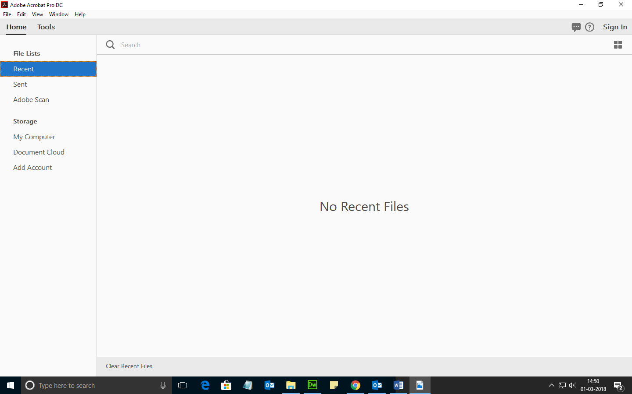

2) Browse and open your saved PDF document which needs to be converted into machine readable document

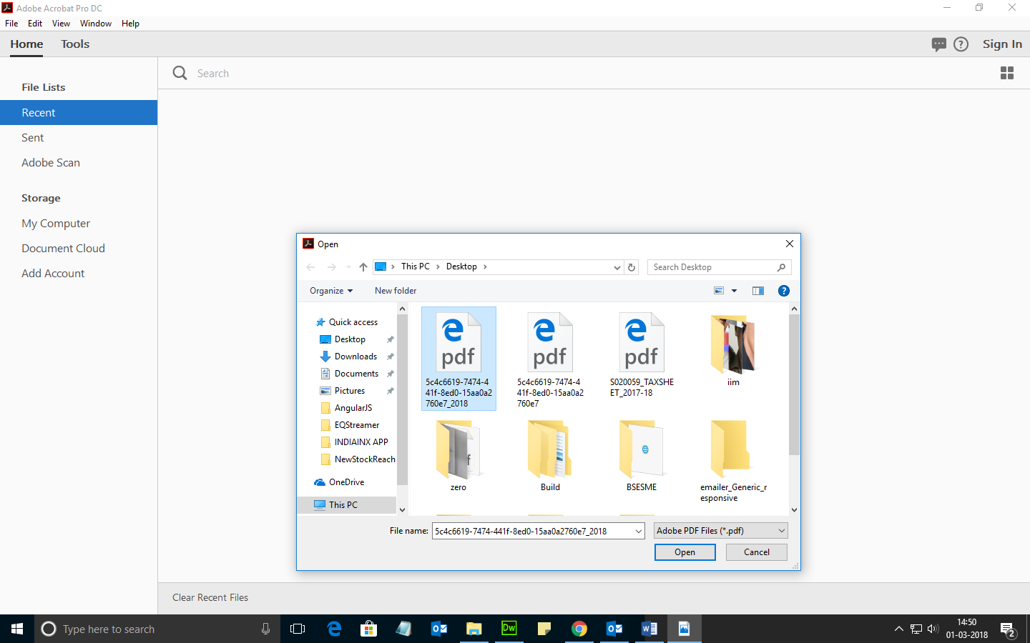
3) Once you have selected the requisite PDF document, which needs to be uploaded in the listing centre, click on Edit PDF button
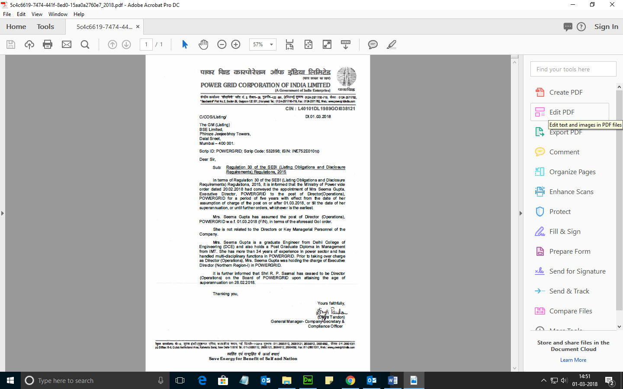

4) After clicking on Edit PDF button, following screen would appear

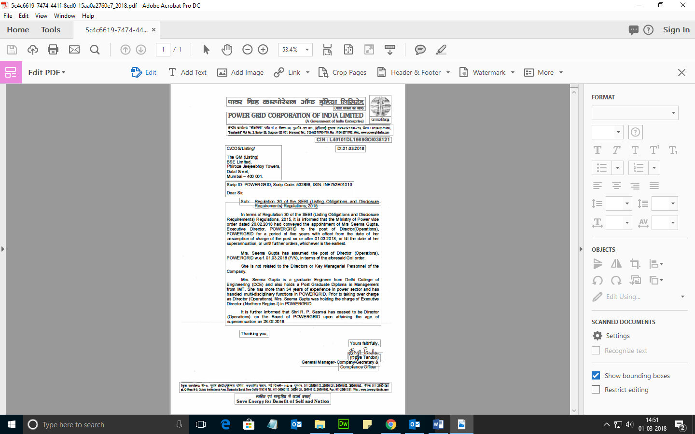

5) Click on File – Save As button, in order to save the document in machine readable format
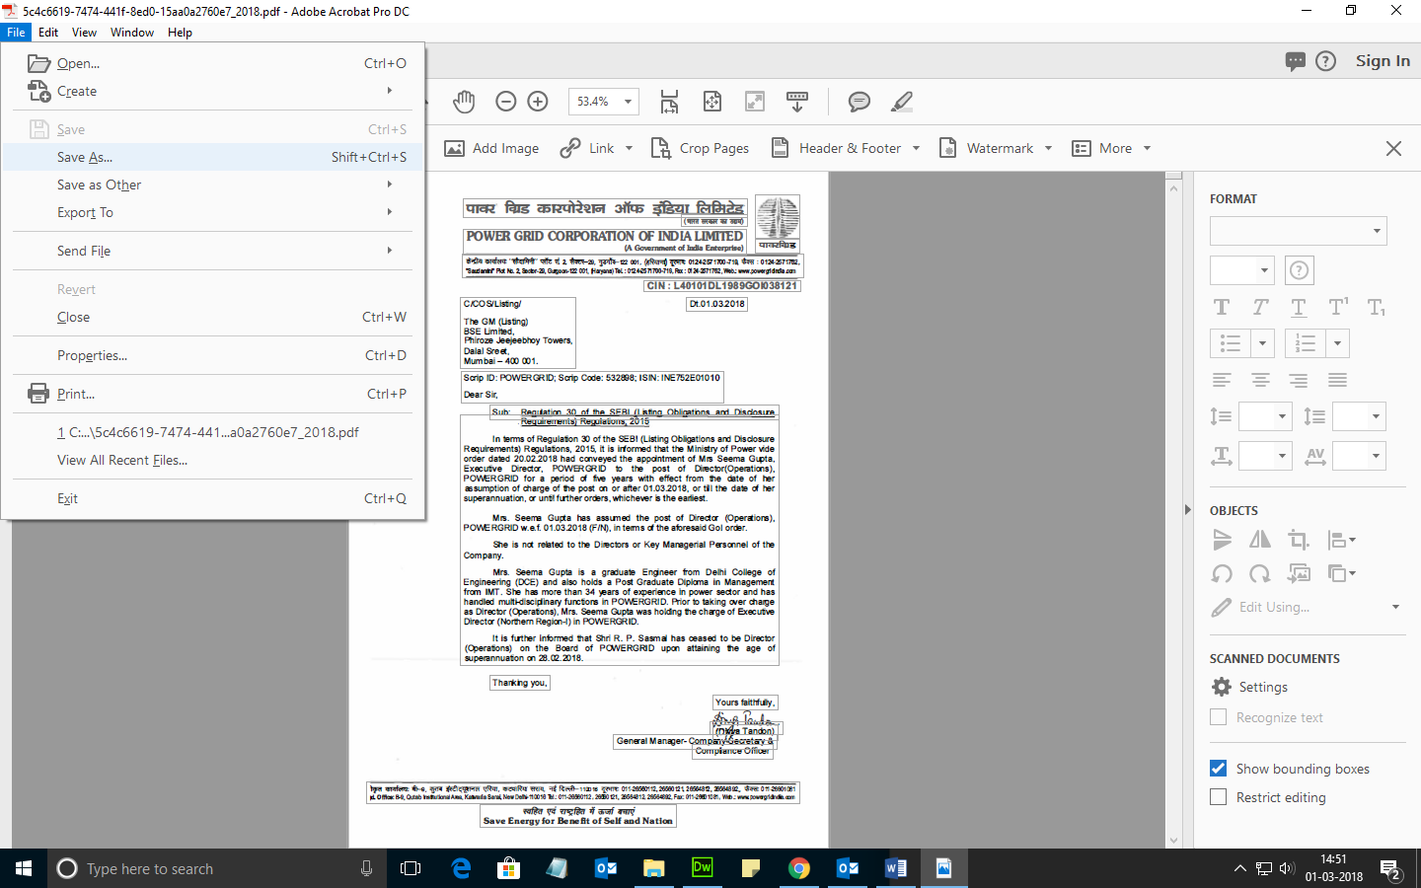

6) Save the document in requisite location in your PC

